

**BOOLEAN RETRIEVAL MODEL**

**DEVELOPER NAME: SHAYAN NOORULLAH**

**DEVELOPMENT FIELD: INFORMATION RETRIEVAL**

**PROGRAM WITH GUI IMPLEMENTATION (WORKING SS):**

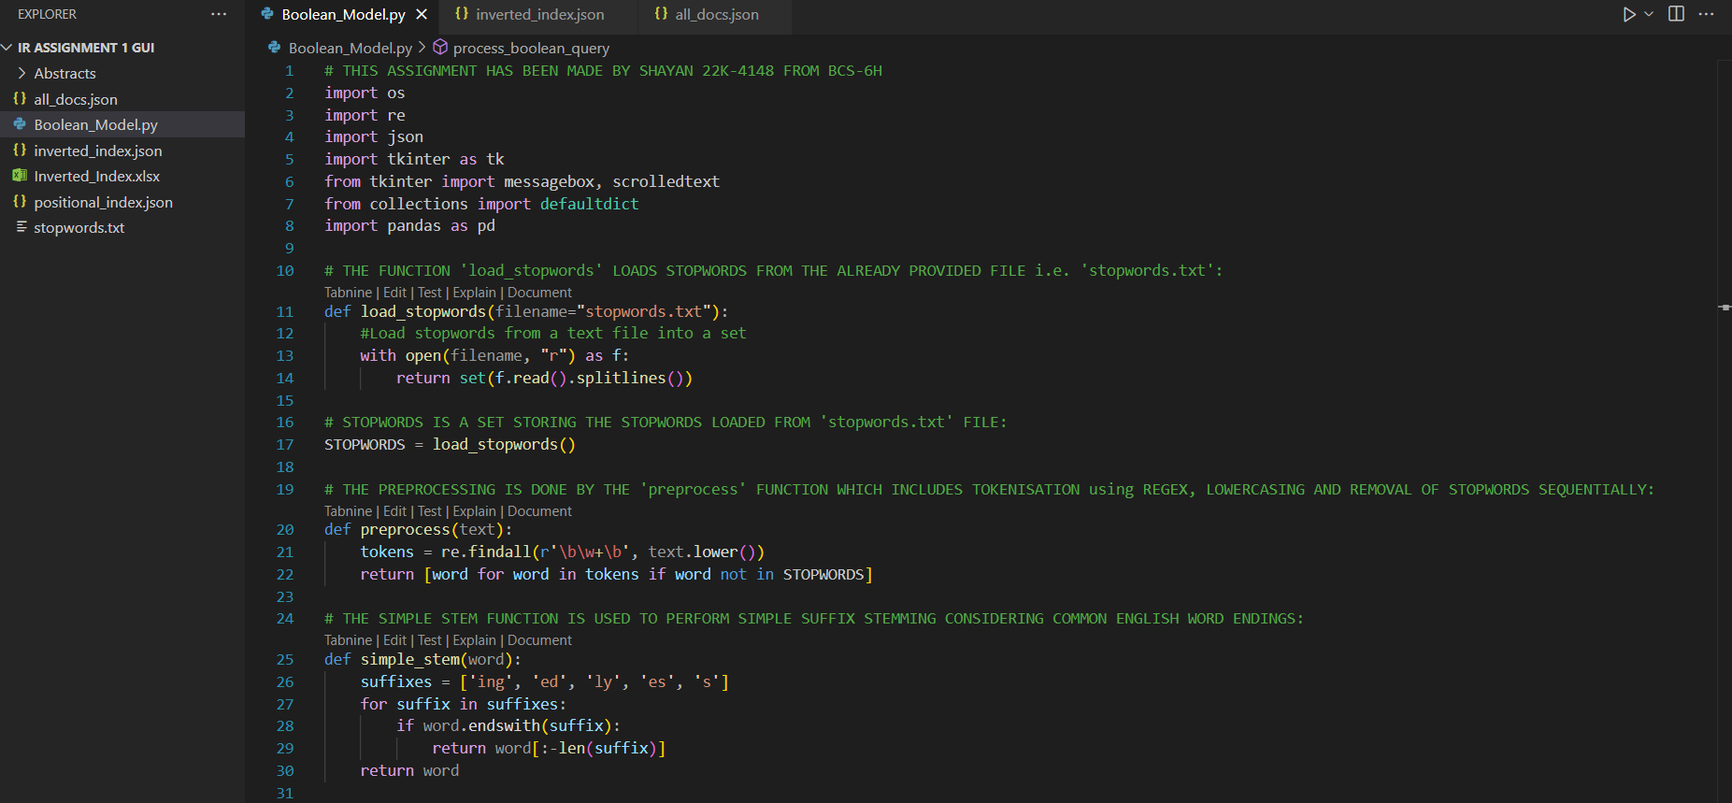



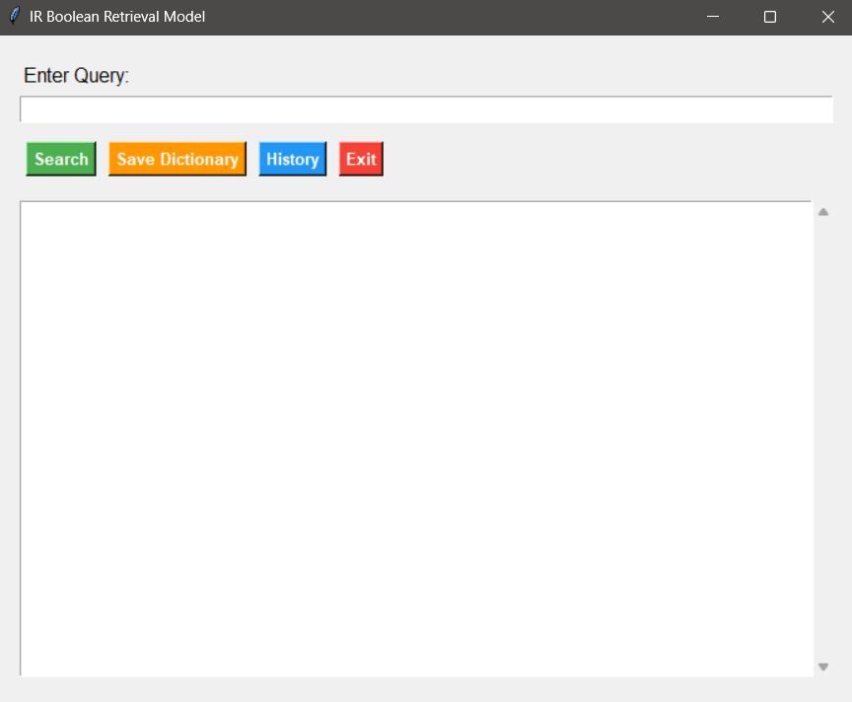

SEARCH QUERY:

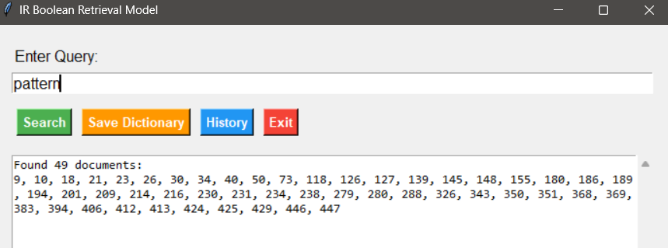

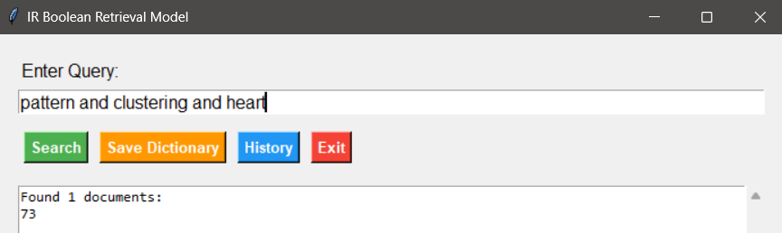

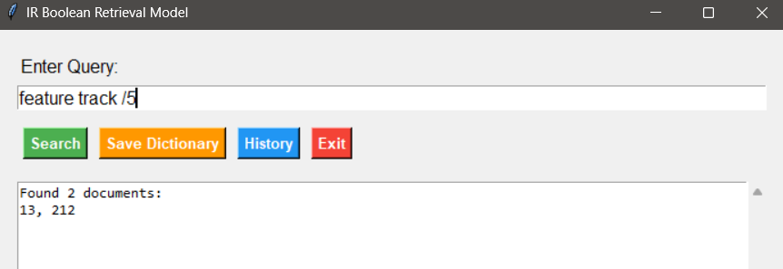

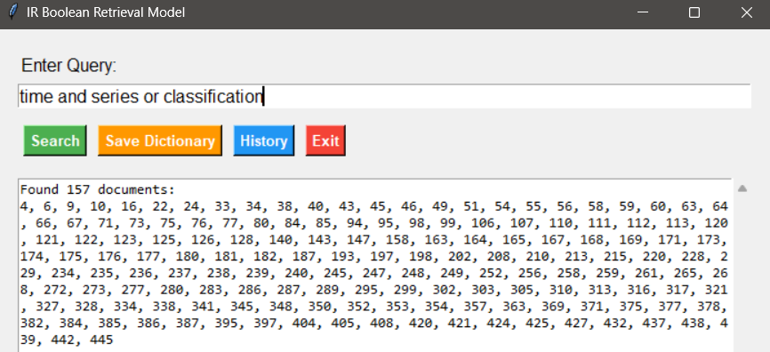

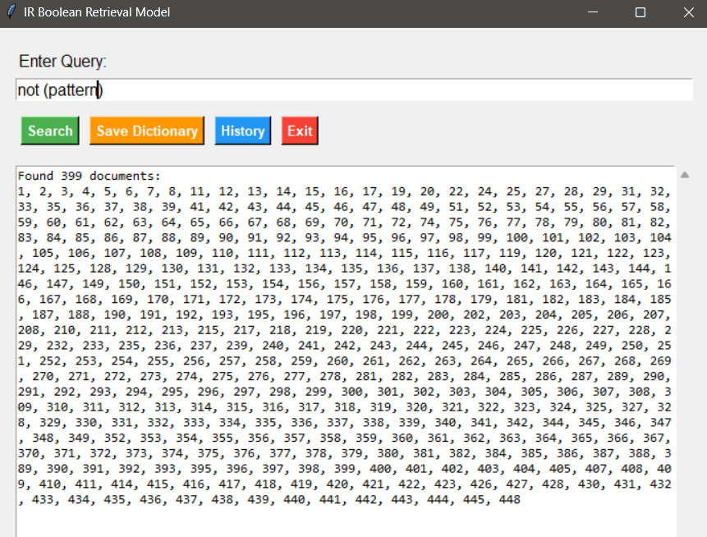

SAVE DICTIONARY:

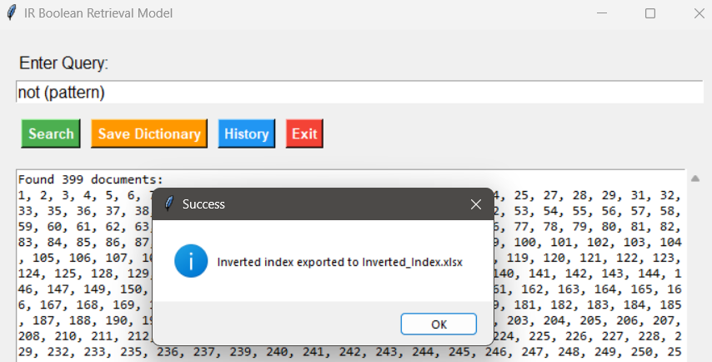

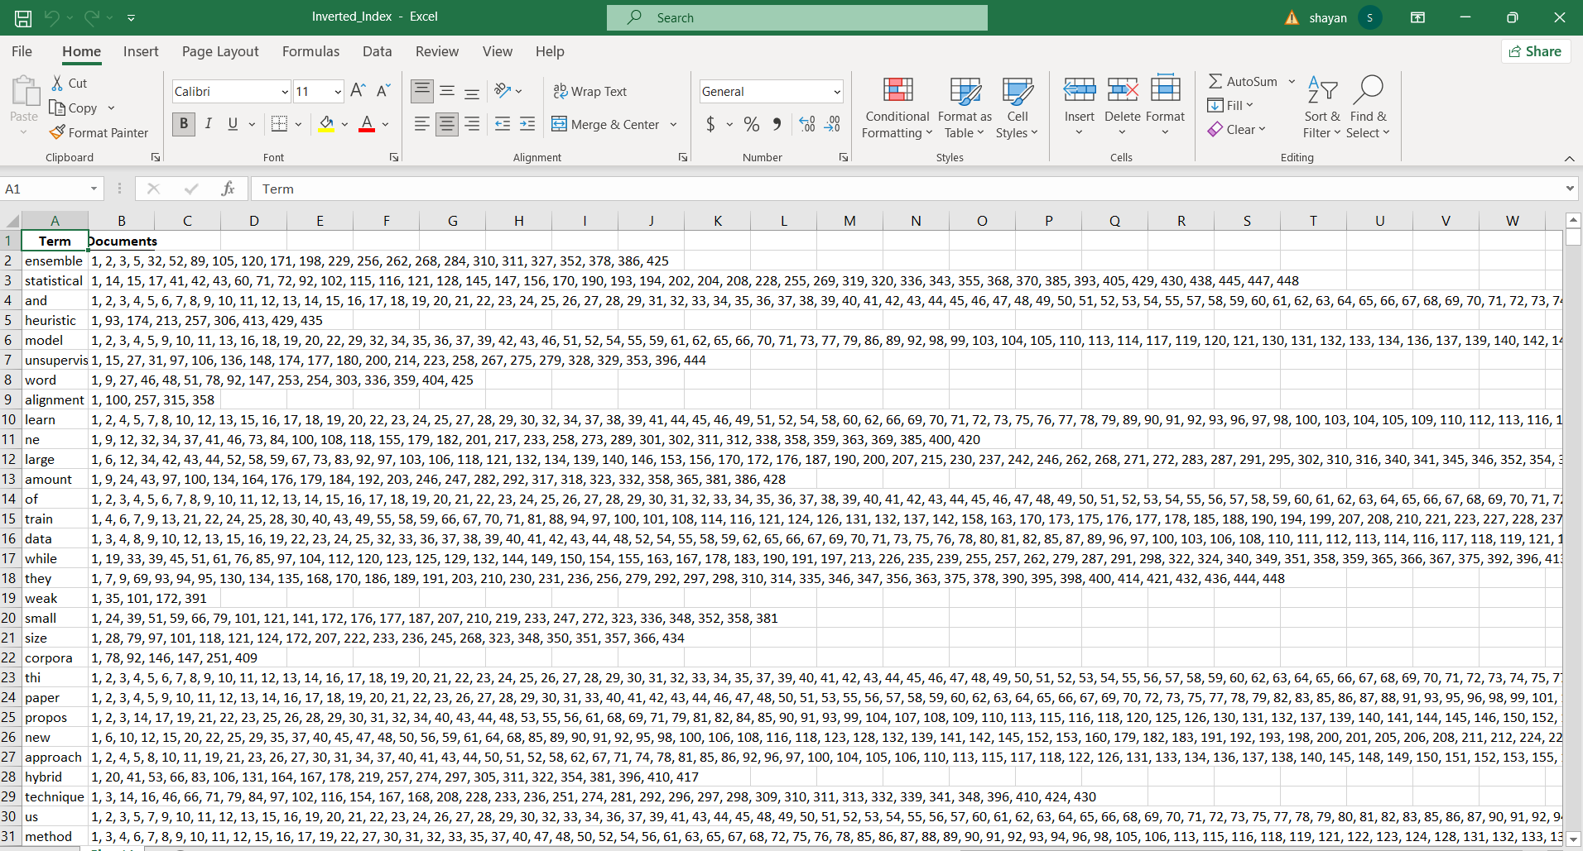

TRACK SEARCH HISTORY:

